

Dear Tenant,
A
11720 Katy Freeway
Suite 400
Houston, Texas 77079
Phone: 713-231-1582
ann.morgan@transwestern.com

According to the terms of your lease, you are required to supply evidence of current insurance coverage. This certificate needs to be updated on a yearly basis. General liability must afford minimum protection of no less than required by your lease. Please refer to the insurance section of your lease for the insurance requirements per your lease.

You may forward this letter to your insurance carrier as it shows the wording that is required to be on the certificate and tends to promote prompt and accurate results.

We appreciate having you as a tenant and thank you for your immediate attention regarding this matter. Please feel free to contact me should you have any questions or concerns. You may also have your insurance company contact me with any questions.

PLEASE HAVE INSURANCE CERTIFICATES SENT TO THE FOLLOWING ADDRESS:

VREC II-TW GMP MOB SPE, LP
c/o Transwestern
11720 Katy Freeway
Suite 400
Houston, Texas 77079

Additional Insured should read:

Re: 2051 Greenhouse Road (your suite number), Houston, Texas 77084

VREC II-TW GMP, MOB SPE, LP A Texas Limited partnership and its parent and affiliates, and its and their officers, directors, partners, agents and employees and Transwestern Property Company SW GP, L.L.C. d/b/a Transwestern are additional insured

Respectfully,

Ann Morgan Property Manager Healthcare Services

TRANSWESTERN
11720 Katy Freeway, Suite 400
Houston, Texas 77079
Direct: 713.231.1582
transwestern.com/healthcare

- Please make sure the ADDL INSD boxes are checked:
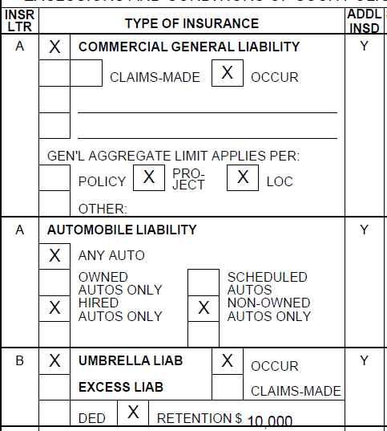

- The Certificate Holder reads:

VREC II-TW GMP MOB SPE, LP
c/o Transwestern
11720 Katy Freeway
Suite 400
Houston, Texas 77079

- The Description Box contains the ADDITIONAL INSURED LANGUAGE and the address/location – 2051 Greenhouse Road Houston, Texas 77084.

